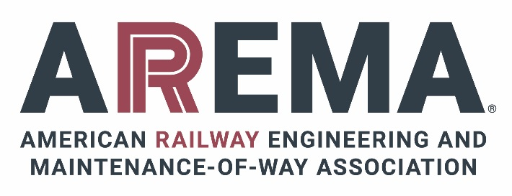

LIST OF CHANGED PARTS IN THE 2026 PORTFOLIO OF TRACKWORK PLANS

Below is a list of plans that are new or revised in the 2026 Portfolio of Trackwork Plans.
Plan No. | Title
- 621-26 | Data and Sections for Rail Bound Manganese Steel Frogs
- 622A/B/C-26 | No. 6, No. 7 and No. 8 Rail Bound Manganese Steel Frogs
- 623 A/B/C-26 | No. 9, No. 10 and No. 11 Rail Bound Manganese Steel Frogs
- 624 A/B/C-26 | No. 12, No. 14 and No. 15 Rail Bound Manganese Steel Frogs
- 625 A/B/C-26 | No. 16, No. 18 and No. 20 Rail Bound Manganese Steel Frogs for Rails 112 lb and Heavier - Heavy Wall
- 641A/B-26 | Solid Manganese Steel Self Guarded Frogs
- 671A/B-26 | Solid Manganese Steel Frogs
- 910-26 | Turnout and Crossover Data for Straight Split Switches
- 911-26 | Location of Joints for Turnouts with Straight Split Switches
- 912-26 | Bills of Switch Ties for Turnouts and Crossovers
- 920-26 | Turnout and Crossover Data for Curved Split Switches
- 921-26 | Location of Joints for Turnouts with Curved Split Switches
- PT 980-26 | Turnout Data for Tangential Turnouts in Pavement Double Flexive Tongue Switch Construction for use in Pavement
- PT 982-26 | 65.62ft (20m), 82.02ft (25m), and 164.04ft (50m) Turnout Solid Frog
- PT 987-26 | 65.62ft (20m) Double Flexive Tongue Switch
- PT 988-26 | 82.02ft (25m) Double Flexive Tongue Switch
- PT 989-26 | 164.04ft (50m) Double Flexive Tongue Switch

